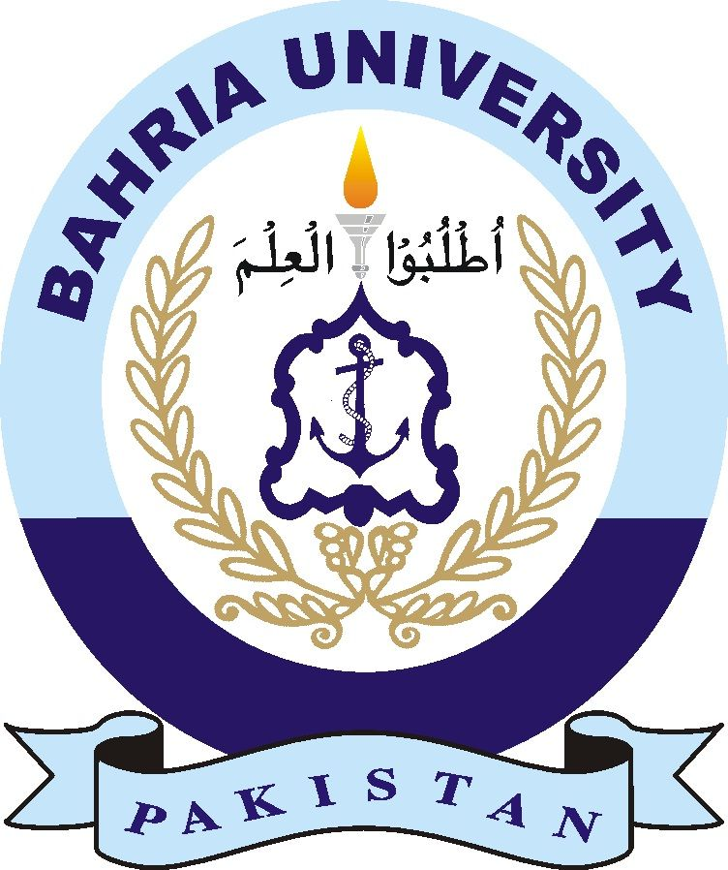

**Waqas Bin Shabeer**

**01-134192-087**

**BSCS**

**8-B**

**01-134192-087@student.bahria.edu.pk**

**Introduction**

**Activitie performed**

1. **Activity no. 1**

* On 10th March 2023, I volunteered for Anti Littering CSP where I collected recyclable items from Drop Lane area of BUIC.
* Evidence (pictures, receipts and video link (if video recorded)

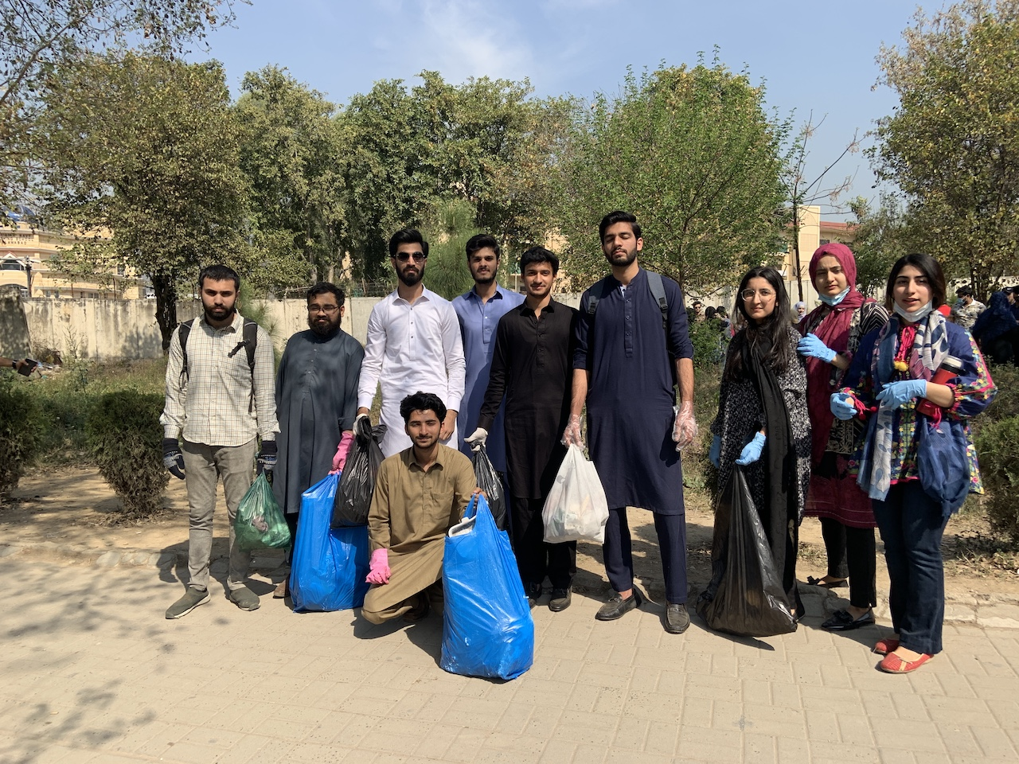

**Experience:**

My overall experience was good

**Feedback:**  
CSP Activities should be held more often in university.